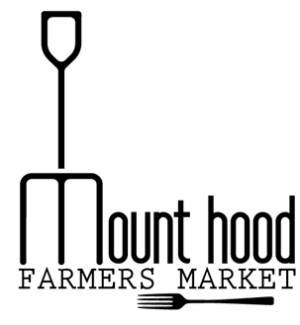
Thank you for your interest in becoming a performer at the Mount Hood Farmer's Market. Please answer the questions below so we can learn more about you and your music:
Group/Performer Name

Number of Members

Contact Person

Email

Phone Number

Website/social media

A description to use in our events calendar

MHFM does not provide sound equipment, do you provide your own?

Performance Availability – please circle dates available
MAY | JUNE | JULY | AUGUST | SEPTEMBER | OCTOBER
05/20 | 06/03 | 07/01 | 08/05 | 09/02 | 10/07
05/27 | 06/10 | 07/08 | 08/12 | 09/09 | 10/14
 | 06/17 | 07/15 | 08/19 | 09/16 | 10/21
 | 06/24 | 07/22 | 08/26 | 09/23
 |  | 07/29 |  | 09/30

____________________________________________________________________________________
Applicant Signature Date

