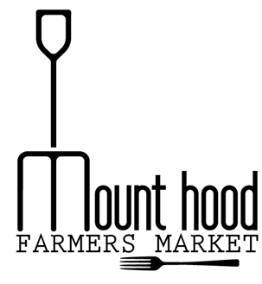
Thank you for your interest in becoming a performer at the Mount Hood Farmer's Market. Please answer the questions below so we can learn more about you and your music:
Group/Performer Name

Number of Members

Contact Person

Email

Phone Number

Address
Website/social media

A description to use in our events calendar
MHFM does not provide sound equipment, do you provide your own, including a tent?

Performance Availability – please circle dates available. Please note that these are times you are available and not a guarantee you will be scheduled for all dates. We do try to rotate through all our musicians. Set up begins at 11am. Market opens at 2pm and closes at 6pm.
MAY | JUNE | JULY | AUGUST | SEPTEMBER | OCTOBER
05/19 | 06/02 | 07/07 | 08/04 | 09/01 | 10/06
05/26 | 06/09 | 07/14 | 08/11 | 09/08 | 10/13
 | 06/16 | 07/21 | 08/18 | 09/15 | 10/20
 | 06/23 | 07/28 | 08/25 | 09/22
 | 06/30 |  |  | 09/29

____________________________________________________________________________________
Applicant Signature Date

